 

ASSIGNMENT ON INTERNET TECHNOLOGY(IT)

Assignment Weightage & Type

60% Portfolio Coursework

Corse: BSc (Hons) CS & DF (Sem_2)

**NAME: AMAN YADAV**

**STUDENT ID: 10722**

**WEEK 8**

**Task 1**

**Question no 1**

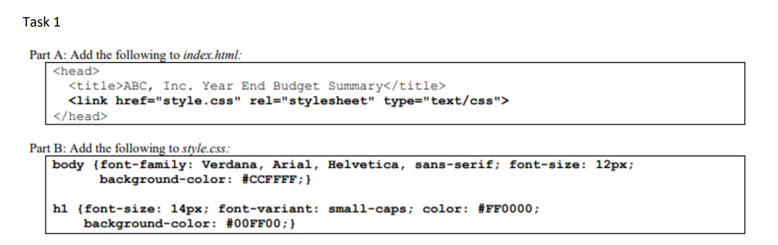

**Ans:**

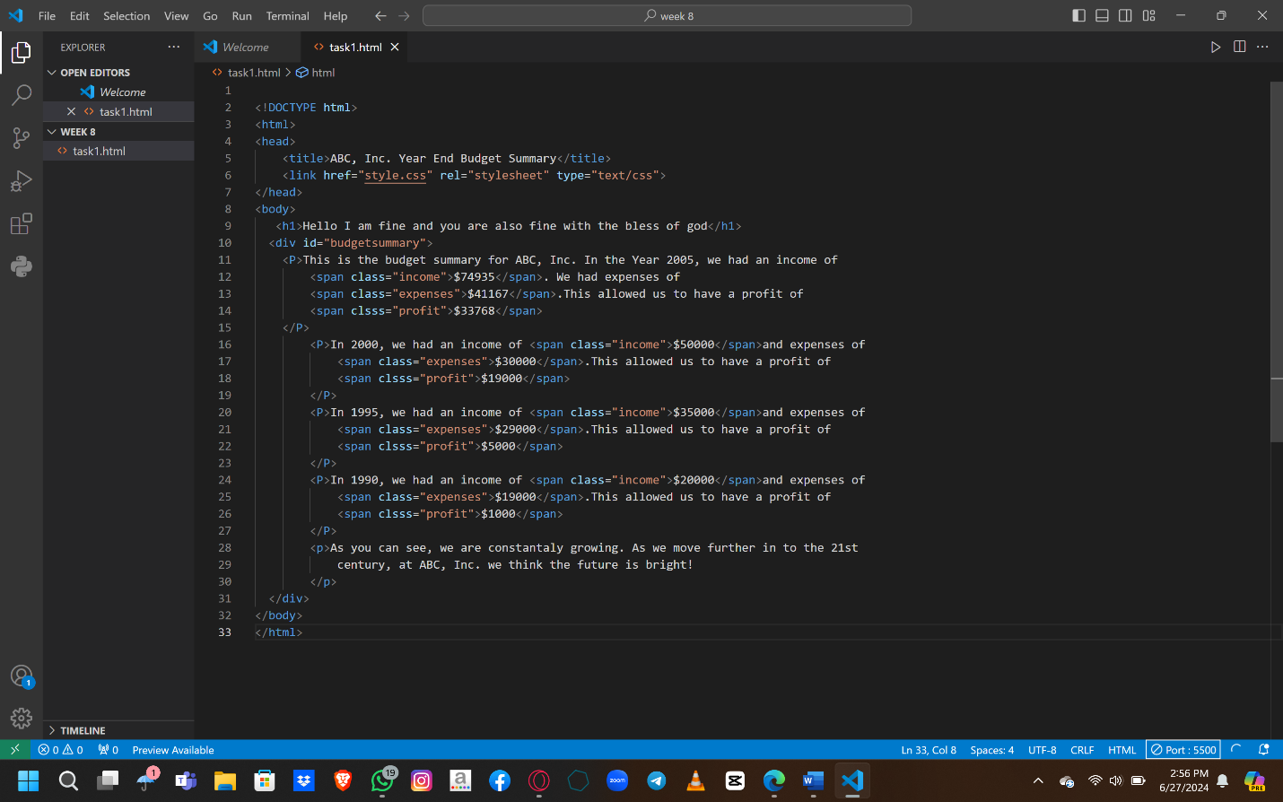

**Output:**

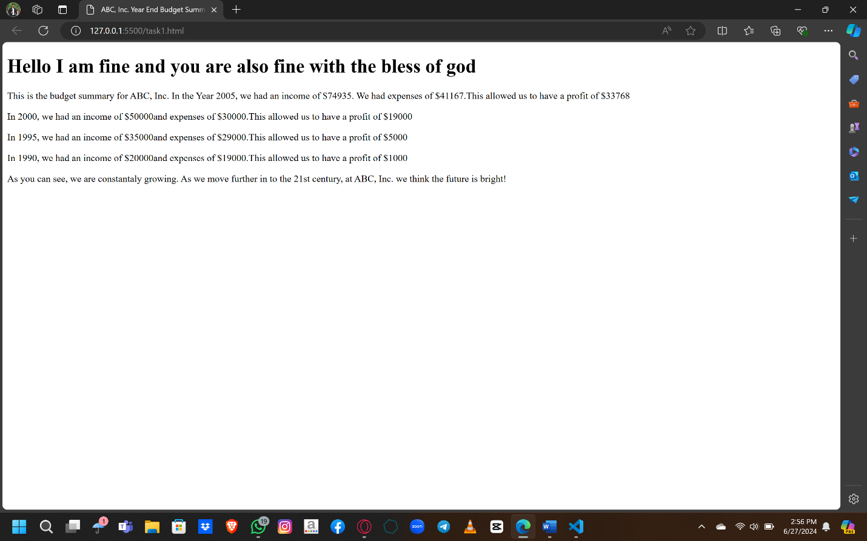

**TASK2:**

**QUESTION NO 2:**

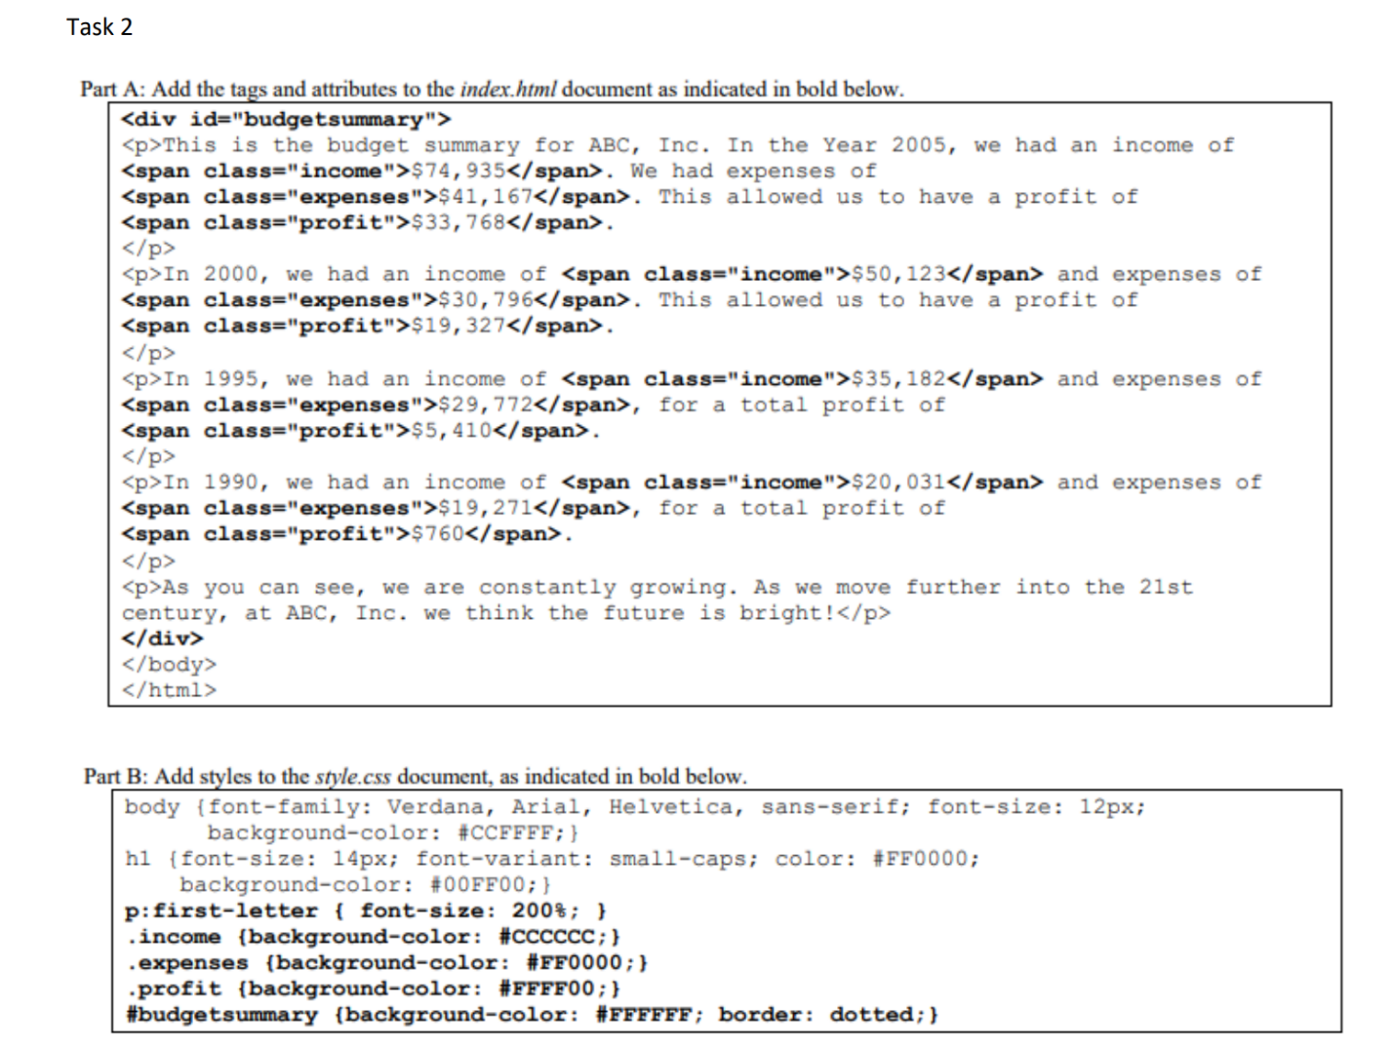

**Ans:**